UNWRAPPING THE STANDARDS
STUDENT EXPECTATION:  2A.3A- formulate systems of equations, including systems consisting of three linear equations in three variables and systems consisting of two equations, the first linear and the second quadratic  2A.3C- solve, algebraically, systems of two equations in two variables consisting of a linear equation and a quadratic equation  2A.3D- determine the reasonableness of solutions to systems of a linear equation and a quadratic equation in two variables  2A.4A- write the quadratic function given three specified points in the plane  2A.4B- write the equation of a parabola using given attributes, including vertex, focus, directrix, axis of symmetry, and direction of opening  2A.4D- transform a quadratic function f(x) = ax² + bx + c to the form f(x) = a(x - h)² + k to identify the different attributes of f(x)  2A.4F- solve quadratic and square root equations  2A.4H- solve quadratic inequalities  2A.7A- add, subtract, and multiply complex numbers  2A.7I- write the domain and range of a function in interval notation, inequalities, and set notation  *Note- This is both units 6 and 7 plus lessons 4 and 5 in unit 5 in math beach. | VERTICAL ALIGNMENT:  - Students distributed to convert from vertex form to standard form in Algebra 1.  - Students solved quadratic equations by completing the square in Algebra 1.  - Students formulated quadratic functions using technology in Algebra 1.  - Students solved quadratic equations by graphing and factoring in Algebra 1.  - Students solved quadratic equations using the quadratic formula in Algebra 1.  - Algebra I wrote systems of two linear equations given a table of values, a graph, and a verbal description.  - Algebra I solved systems of two linear equations with two variables for mathematical and real-world problems.  - Algebra I estimated graphically the solutions to systems of two linear equations with two variables in real-world problems.  - Algebra I wrote quadratic functions when given real solutions and graphs of their related equations.  - Algebra I formulated a quadratic function using technology.  - Algebra I wrote quadratic equations in vertex form (f(x) = a(x – h)² + k), and rewrote from vertex form to standard form (f(x) = ax² + bx + c).  - Algebra II introduces writing the equation of a parabola using attributes.  - Algebra I solved quadratic equations having real solutions by completing the square.  *Black is from Math beach. Blue is from TEKS Resource*
*Highlighted TEKs are considered priority*

CONTEXT(S)
- Word Problem  - Verbal Description  - Chart/Table | - Diagram/Image  - Number Line  - Manipulative/Realia | - Equation/Expression  - Formula  - Geometric Figures | - Others:

KEY VOCABULARY
- Complex conjugates  - Complex number  - Directrix  - Focus  - Imaginary number  - |p|  - Parabola  - x-intercept(s)  - Zeros  - Standard form  - Substitution method  - Symmetric point | - Axis of symmetry  - Completing the square  - Discriminant  - Factoring  - Fundamental Theorem of Algebra  - Gaussian method  - Horizontal shift  - Inverse matrix  - Locus of points  - Maximum | - Minimum Operations of complex numbers  - Quadratic equation  - Quadratic formula  - Quadratic function  - Quadratic inequality  - Real numbers  - Roots  - Solutions  - Vertex  - Vertex form

SHOW  What will students need to be able to show in their work to demonstrate mastery? | KNOW  What do students need to know to be able to show mastery of this standard?
Grading for this unit: Skills Based  Create a solving grade.  Create a formulate grade.  Create a graphing grade. | 1.

POSSIBLE LEARNING TARGETS (see SAT problems for ideas for instruction)
Solving: (3C, 3D (solving with reasonableness), 4F, not 4H)

I can solve quadratic equations.
- I can solve quadratic equations by factoring.
- I can solve quadratic equations by completing the square.
- I can solve quadratic equations by using the quadratic formula.
- I can justify my solutions for quadratic equations from the graph.

I can solve systems of 2 equations with 2 variables (one quadratic and one linear).
- Look at how math beach does this.

Formulate (3A, 4A, 4B)
Note: 4A - teach directrix, but don’t asses

I can formulate systems of equations, one linear and one quadratic. (3A)
I can write a quadratic function, given 3 points. (3A)
I can write the equation of a parabola, given its attributes.
- Vertex, focus, directrix, axis of symmetry, and direction of opening

Graphing: (4D, 7I)

I can transform a quadratic function from standard form to vertex form. (4D)
I can identify the different attributes of a quadratic function.
- Vertex, focus, directrix, axis of symmetry, max, min, direction of opening, domain, range, ROXS, and y-intercept

TEK 2A.3A
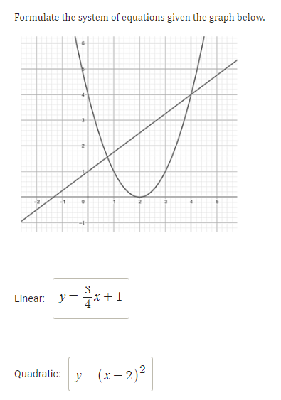

TEK 2A.4F

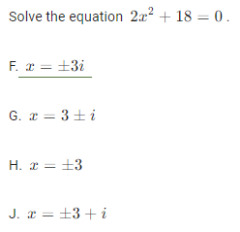

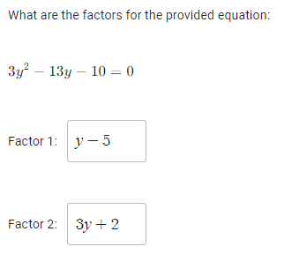

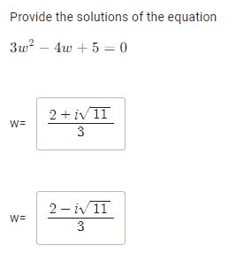

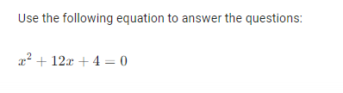
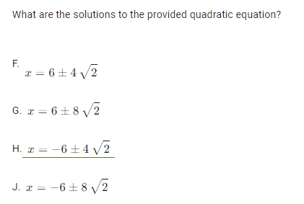
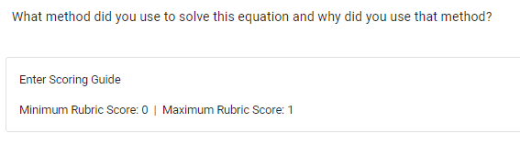

TEK 2A.7I
